The 3-3-2 Formation

Building on the way we played last year, (2-3-2) we will be adding an additional defender this year. We will discuss that players' role later on, for now I want to go over player movement (especially the forwards) as the ball moves across the field and towards the goal.

This year I would really like to see our forwards working together. I want the weak side forward to “stretch” the defense, while the other forward comes to the ball.

If the forward does not get the ball, I want him the “check out” (move away from the ball) and the other forward come to the ball. As the ball moves across the field (fig. 2.and 3.), notice how the players without the ball put themselves in position to be supportive.

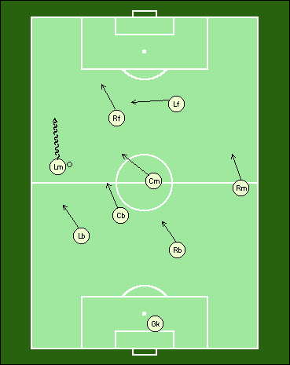

Now the left midfielder has choices to make. As the attack progresses into the attacking third, the players without the ball continue to move into a supportive position.

